# Theory:

**Enterprise Application**

Have you ever thought of various products and services offered by a Bank. Have a look at the diagram below.

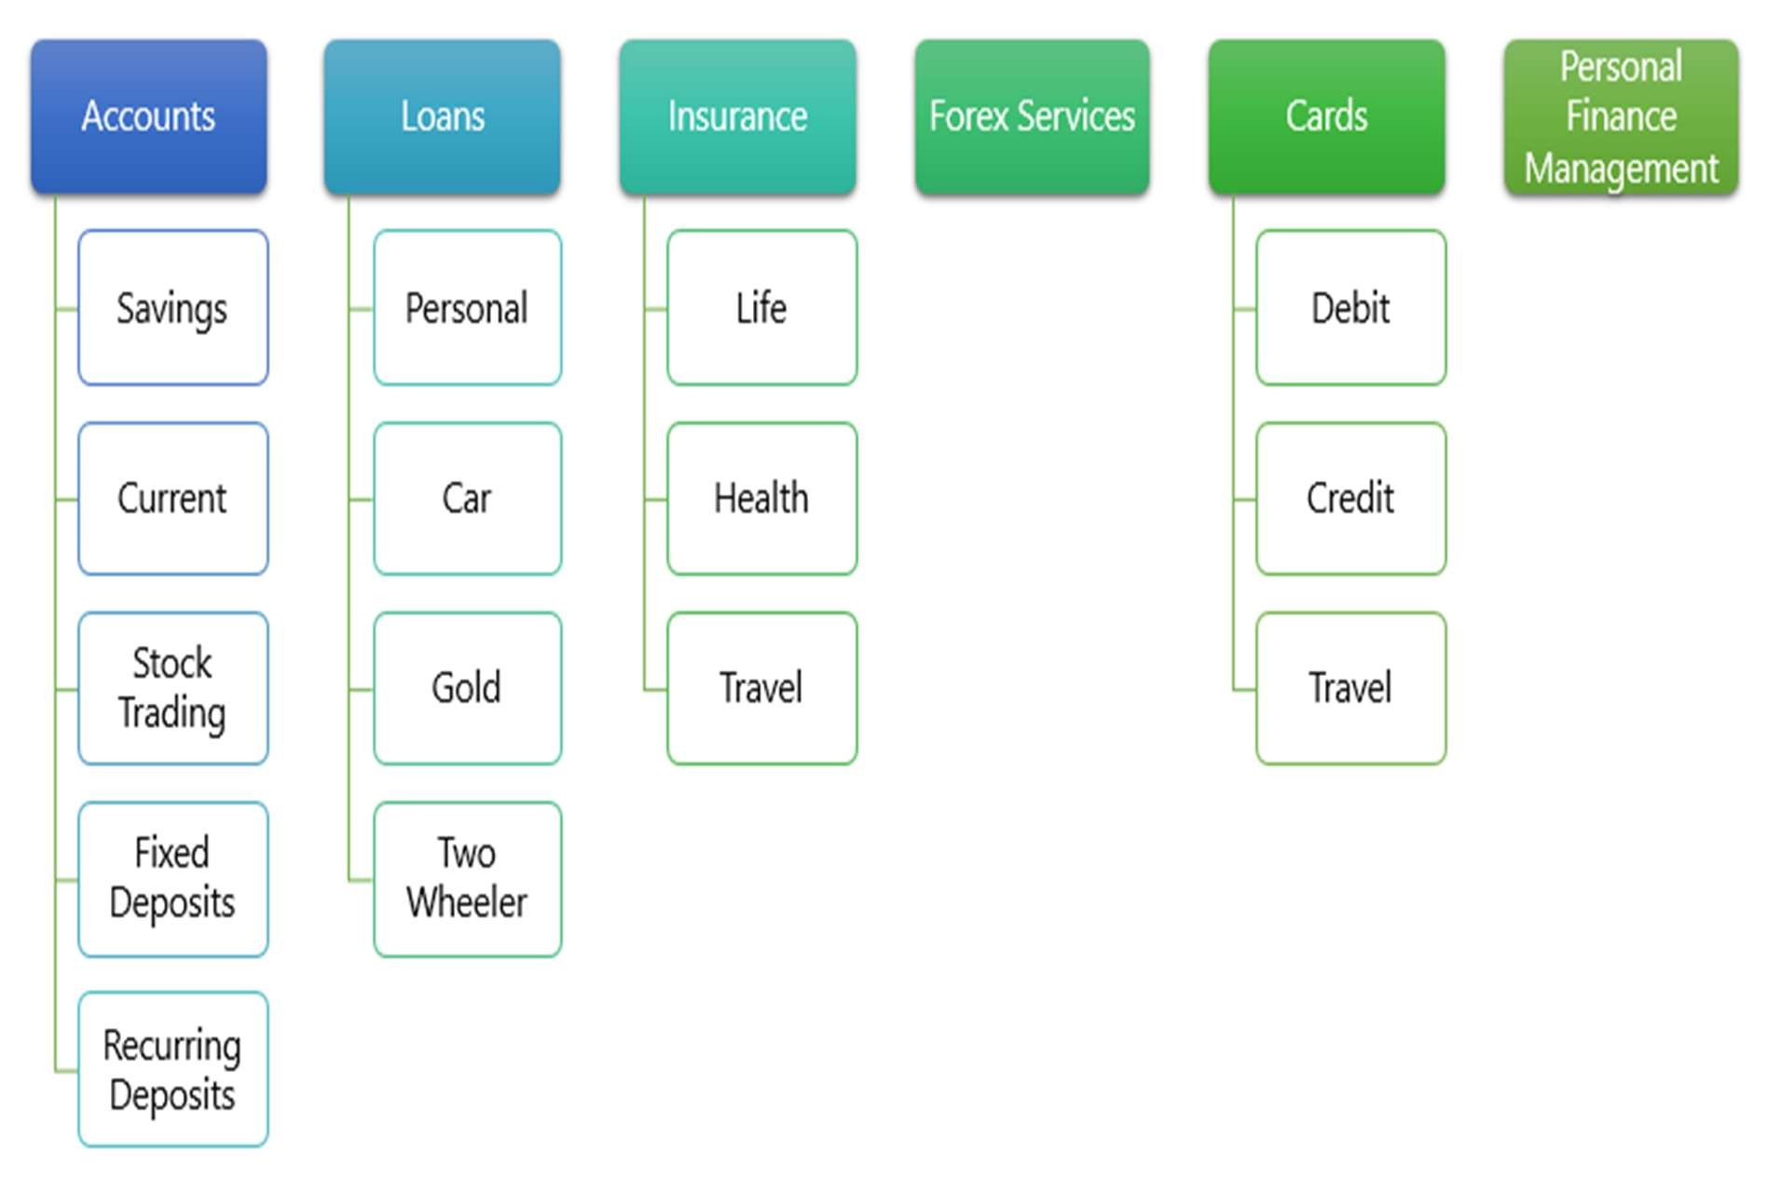

Still there are few aspects missing like Phone Banking, SMS Banking, Micro Finance, etc.

Let us take one service "Savings Account" from the above diagram. Few aspects associated with Savings Account is defined below and this is not an exhaustive list.

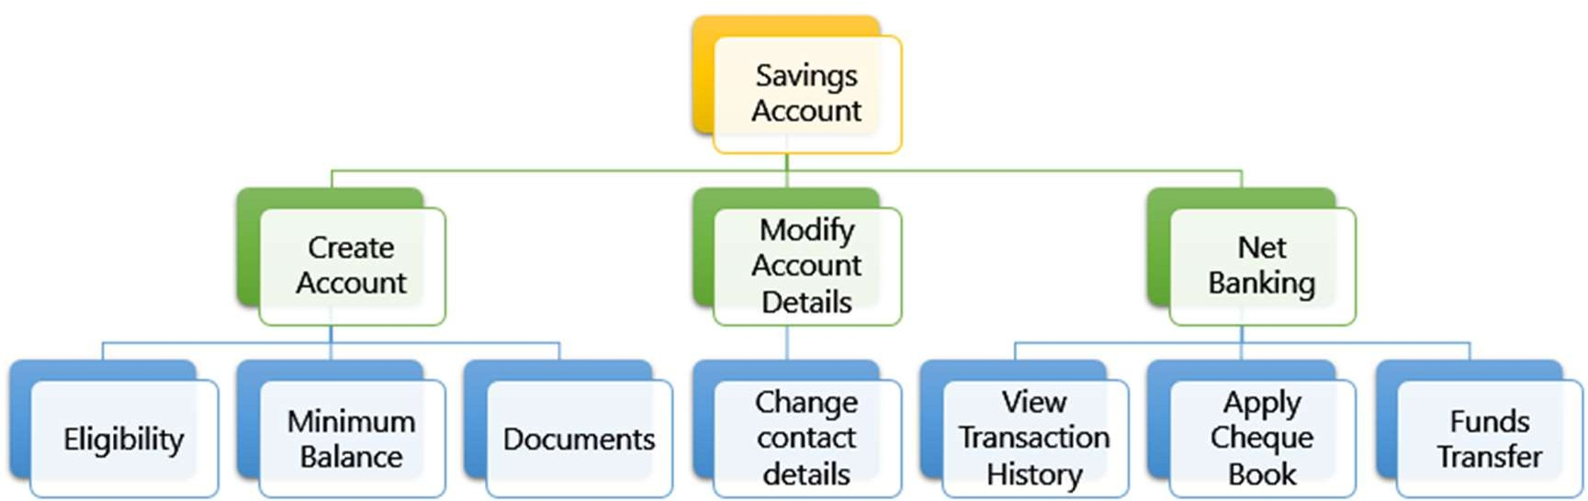

Systems and applications that manages the service levels of these kind of organizations are called **Enterprise Application**.

## Activity

* Go to https://[www.airtel.in/](http://www.airtel.in/) and find out all products and services that are offered.
* SME to write the services offered by airtel on the board based on inputs from the learners.

# Creating Microservices for account and loan

In this hands on exercises, we will create two microservices for a bank. One microservice for handing accounts and one for handling loans.

Each microservice will be a specific independent Spring RESTful Webservice maven project having it's own pom.xml. The only difference is that, instead of having both account and loan as a single application, it is split into two different applications. These webservices will be a simple service without any backend connectivity.

Follow steps below to implement the two microservices:

## Account Microservice

* Create folder with employee id in D: drive
* Create folder named 'microservices' in the new folder created in previous step. This folder will contain all the sample projects that we will create for learning microservices.
* Open https://start.spring.io/ in browser
* Enter form field values as specified below:
  + **Group:** com.cognizant
  + **Artifact:** account
* Select the following modules
  + Developer Tools > Spring Boot DevTools
  + Web > Spring Web
* Click generate and download the zip file
* Extract 'account' folder from the zip and place this folder in the 'microservices' folder created earlier
* Open command prompt in account folder and build using mvn clean package command
* Import this project in Eclipse and implement a controller method for getting account details based on account number. Refer specification below:
  + Method: GET
  + Endpoint: /accounts/{number}
  + Sample Response. Just a dummy response without any backend connectivity.

{ number: "00987987973432", type: "savings", balance: 234343 }

* Launch by running the application class and test the service in browser

**Program:**

**pom.xml:**

<project xmlns="http://maven.apache.org/POM/4.0.0"

xmlns:xsi="http://www.w3.org/2001/XMLSchema-instance"

xsi:schemaLocation="http://maven.apache.org/POM/4.0.0

http://maven.apache.org/xsd/maven-4.0.0.xsd">

<modelVersion>4.0.0</modelVersion>

<parent>

<groupId>org.springframework.boot</groupId>

<artifactId>spring-boot-starter-parent</artifactId>

<version>2.7.18</version>

<relativePath/>

</parent>

<groupId>com.cognizant</groupId>

<artifactId>account</artifactId>

<version>0.0.1-SNAPSHOT</version>

<properties>

<java.version>11</java.version>

</properties>

<dependencies>

<dependency>

<groupId>org.springframework.boot</groupId>

<artifactId>spring-boot-starter-web</artifactId>

</dependency>

</dependencies>

<build>

<plugins>

<plugin>

<groupId>org.apache.maven.plugins</groupId>

<artifactId>maven-compiler-plugin</artifactId>

<version>3.8.1</version>

<configuration>

<source>11</source>

<target>11</target>

</configuration>

</plugin>

</plugins>

</build>

</project>

**AccountApplication.java:**

package com.cognizant.account;

import org.springframework.boot.SpringApplication;

import org.springframework.boot.autoconfigure.SpringBootApplication;

@SpringBootApplication

public class AccountApplication {

public static void main(String[] args) {

SpringApplication.run(AccountApplication.class, args);

}

}

**AccountController.java:**

package com.cognizant.account;

import org.springframework.web.bind.annotation.GetMapping;

import org.springframework.web.bind.annotation.PathVariable;

import org.springframework.web.bind.annotation.RestController;

@RestController

public class AccountController {

@GetMapping("/")

public String home() {

return "Spring Boot Account Service is running!";

}

@GetMapping("/accounts/{number}")

public Account getAccount(@PathVariable String number) {

return new Account(number, "savings", 10000);

}

static class Account {

private String number;

private String type;

private int balance;

public Account(String number, String type, int balance) {

this.number = number;

this.type = type;

this.balance = balance;

}

public String getNumber() { return number; }

public String getType() { return type; }

public int getBalance() { return balance; }

}

}

**Application.properties:**

server.port=3000

**.replit:**

language = "java"

run = "mvn spring-boot:run"

[nix]

packages = ["maven"]

[[ports]]

localPort = 3000

externalPort = 80

**Output:**

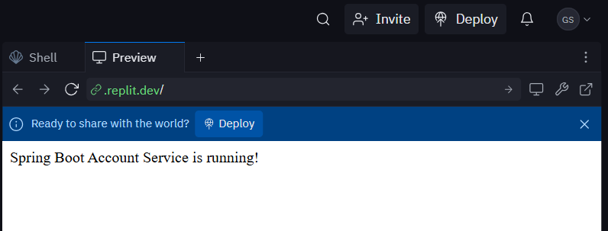

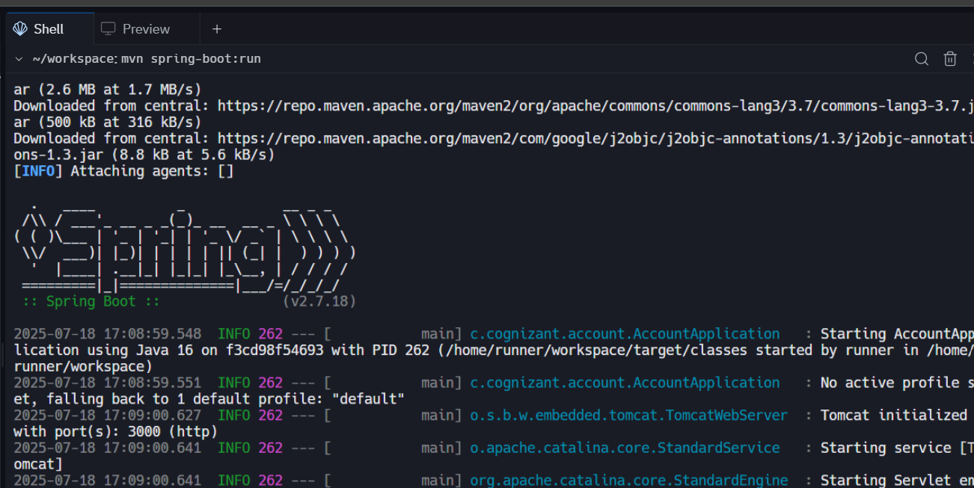

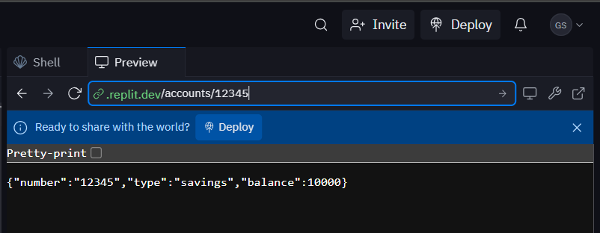

## Loan Microservice

* Follow similar steps specified for Account Microservice and implement a service API to get loan account details
  + Method: GET
  + Endpoint: /loans/{number}
  + Sample Response. Just a dummy response without any backend connectivity.

{ number: "H00987987972342", type: "car", loan: 400000, emi: 3258, tenure:

18 }

* Launching this application by having account service already running
* This launch will fail with error that the bind address is already in use
* The reason is that each one of the service is launched with default port number as 8080. Account service is already using this port and it is not available for loan service.
* Include "server.port" property with value 8081 and try launching the application
* Test the service with 8081 port

Now we have two microservices running on different ports.

**NOTE:** The console window of Eclipse will have both the service console running. To switch between different consoles use the monitor icon within the console view.

**Program:**

**pom.xml:**

<project xmlns="http://maven.apache.org/POM/4.0.0"

xmlns:xsi="http://www.w3.org/2001/XMLSchema-instance"

xsi:schemaLocation="http://maven.apache.org/POM/4.0.0

http://maven.apache.org/xsd/maven-4.0.0.xsd">

<modelVersion>4.0.0</modelVersion>

<groupId>com.cognizant</groupId>

<artifactId>loan</artifactId>

<version>0.0.1-SNAPSHOT</version>

<name>loan</name>

<parent>

<groupId>org.springframework.boot</groupId>

<artifactId>spring-boot-starter-parent</artifactId>

<version>2.7.18</version>

<relativePath/>

</parent>

<dependencies>

<dependency>

<groupId>org.springframework.boot</groupId>

<artifactId>spring-boot-starter-web</artifactId>

</dependency>

</dependencies>

<build>

<plugins>

<plugin>

<groupId>org.springframework.boot</groupId>

<artifactId>spring-boot-maven-plugin</artifactId>

</plugin>

</plugins>

</build>

</project>

**LoanApplication.java:**

package com.cognizant.loan;

import org.springframework.boot.SpringApplication;

import org.springframework.boot.autoconfigure.SpringBootApplication;

@SpringBootApplication

public class LoanApplication {

public static void main(String[] args) {

SpringApplication.run(LoanApplication.class, args);

}

}

**LoanController.java:**

package com.cognizant.loan;

import org.springframework.web.bind.annotation.GetMapping;

import org.springframework.web.bind.annotation.PathVariable;

import org.springframework.web.bind.annotation.RestController;

@RestController

public class LoanController {

@GetMapping("/") // home page to avoid white label

public String home() {

return "Loan service is up and running!";

}

@GetMapping("/loans/{id}")

public Loan getLoan(@PathVariable String id) {

return new Loan(id, "Personal Loan", 250000);

}

static class Loan {

private String id;

private String type;

private int amount;

public Loan(String id, String type, int amount) {

this.id = id;

this.type = type;

this.amount = amount;

}

public String getId() { return id; }

public String getType() { return type; }

public int getAmount() { return amount; }

}

}

**application.properties:**

server.port=8081

**.replit:**

language = "bash"

run = "mvn spring-boot:run"

[nix]

packages = ["maven"]

[[ports]]

localPort = 8081

externalPort = 80

**Output:**

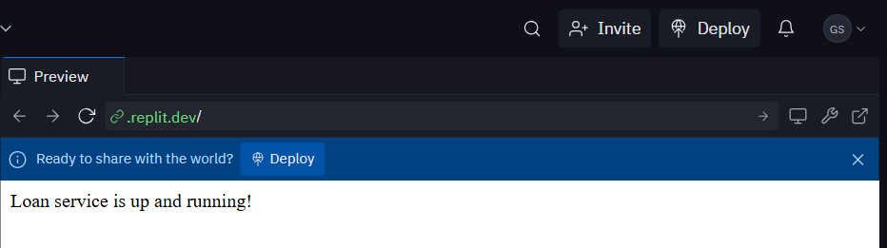

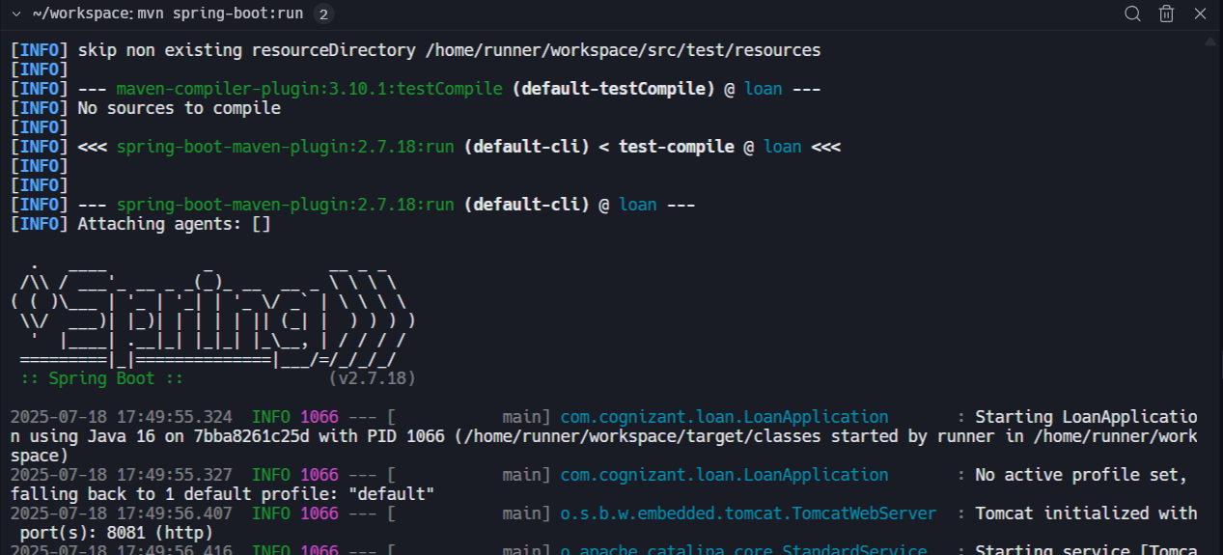

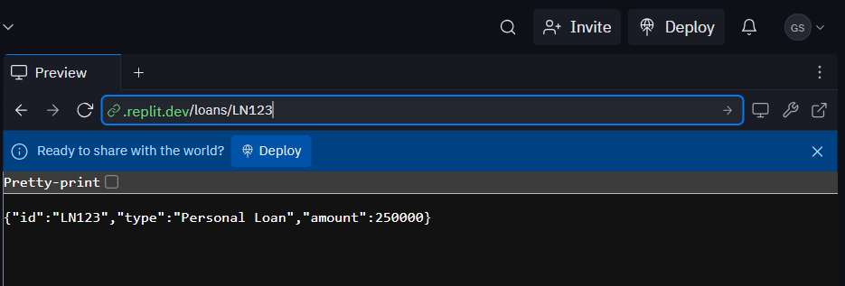

# Create Eureka Discovery Server and register microservices

Eureka Discovery Server holds a registry of all the services that are available for immediate consumption. Anybody whom wants to consume a RESTful Web Service can come to the discovery server and find out what is available and ready for consumption. Eureka Discovery Server is part of spring cloud module.

Follow steps below to implement:

## Create and Launch Eureka Discovery Server

* Using https://start.spring.io generate a project with following configuration:
  + Group: com.cognizant
  + Artifact: eureka-discovery-server
  + Module: Spring Cloud Discovery > Eureka Server
* Download the project, build it using maven in command line
* Import the project in Eclipse
* Include @EnableEurekaServer in

class EurekaDiscoveryServerApplication

* Include the following configurations in application.properties:

server.port=8761

eureka.client.register-with-eureka=false eureka.client.fetch-registry=false

logging.level.com.netflix.eureka=OFF logging.level.com.netflix.discovery=OFF

* The above configuration runs the discovery service in port 8761
* The eureka properties prohibits direct registration of services, instead discovery server will find available services and register them.
* Launch the service by running the application class
* The discovery service can be view by launching [http://locahost:8761](http://locahost:8761/) in the browser.
* This will display the discover server details
* Look into the section "Instances currently registered with Eureka", which will have an empty list
* Follow steps below to add account and loan service to this discovery server.

**Program:**

**eureka-discovery-server(folder):**

**EurekaDiscoveryServerApplication.java:**

package com.example.eureka;

import org.springframework.boot.SpringApplication;

import org.springframework.boot.autoconfigure.SpringBootApplication;

import org.springframework.cloud.netflix.eureka.server.EnableEurekaServer;

@SpringBootApplication

@EnableEurekaServer

public class EurekaDiscoveryServerApplication {

public static void main(String[] args) {

SpringApplication.run(EurekaDiscoveryServerApplication.class, args);

}

}

**application.properties:**

server.port=8761

spring.application.name=eureka-discovery-server

eureka.client.register-with-eureka=false

eureka.client.fetch-registry=false

logging.level.com.netflix.eureka=OFF

**pom.xml:**

<project xmlns="http://maven.apache.org/POM/4.0.0"

xmlns:xsi="http://www.w3.org/2001/XMLSchema-instance"

xsi:schemaLocation="http://maven.apache.org/POM/4.0.0

http://maven.apache.org/xsd/maven-4.0.0.xsd">

<modelVersion>4.0.0</modelVersion>

<groupId>com.cognizant</groupId>

<artifactId>eurekadiscoveryserver</artifactId>

<version>0.0.1-SNAPSHOT</version>

<packaging>jar</packaging>

<name>eureka-discovery-server</name>

<description>Spring Boot Eureka Discovery Server</description>

<parent>

<groupId>org.springframework.boot</groupId>

<artifactId>spring-boot-starter-parent</artifactId>

<version>3.1.5</version>

<relativePath/> <!-- lookup parent from repository -->

</parent>

<properties>

<java.version>17</java.version>

<spring-cloud.version>2022.0.4</spring-cloud.version>

</properties>

<dependencies>

<!-- Eureka Server -->

<dependency>

<groupId>org.springframework.cloud</groupId>

<artifactId>spring-cloud-starter-netflix-eureka-server</artifactId>

</dependency>

<dependency>

<groupId>org.springframework.boot</groupId>

<artifactId>spring-boot-starter-web</artifactId>

</dependency>

<dependency>

<groupId>org.springframework.boot</groupId>

<artifactId>spring-boot-starter-actuator</artifactId>

</dependency>

<dependency>

<groupId>jakarta.annotation</groupId>

<artifactId>jakarta.annotation-api</artifactId>

</dependency>

</dependencies>

<dependencyManagement>

<dependencies>

<dependency>

<groupId>org.springframework.cloud</groupId>

<artifactId>spring-cloud-dependencies</artifactId>

<version>${spring-cloud.version}</version>

<type>pom</type>

<scope>import</scope>

</dependency>

</dependencies>

</dependencyManagement>

<build>

<plugins>

<plugin>

<groupId>org.springframework.boot</groupId>

<artifactId>spring-boot-maven-plugin</artifactId>

<version>3.1.5</version>

</plugin>

</plugins>

</build>

</project>

**Output:**

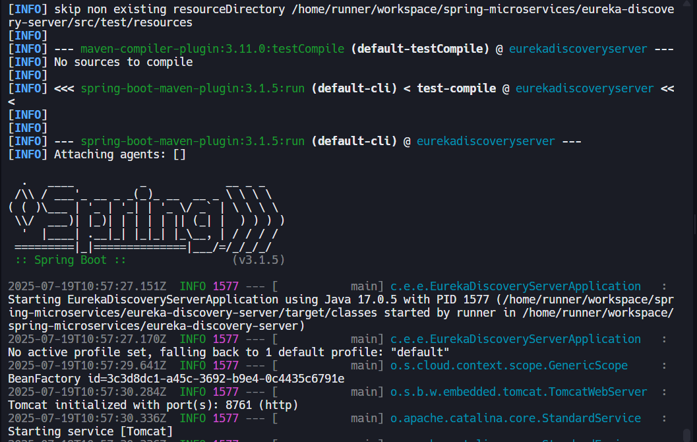

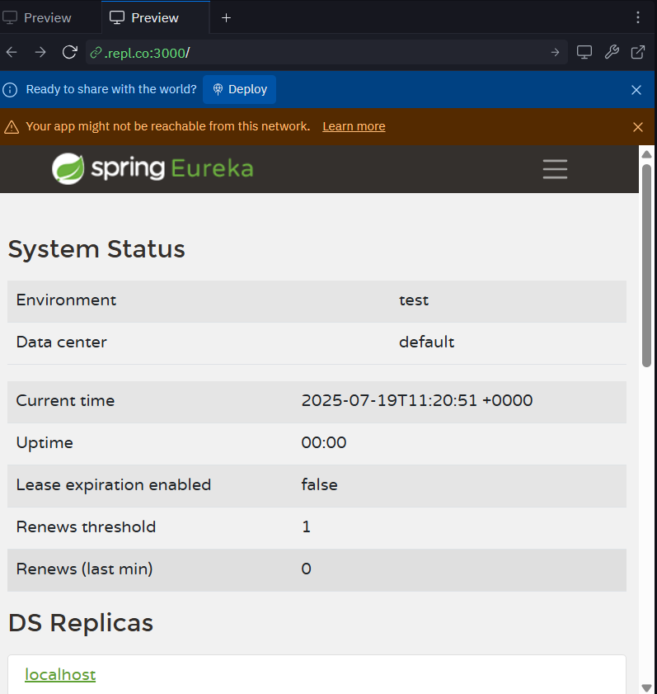

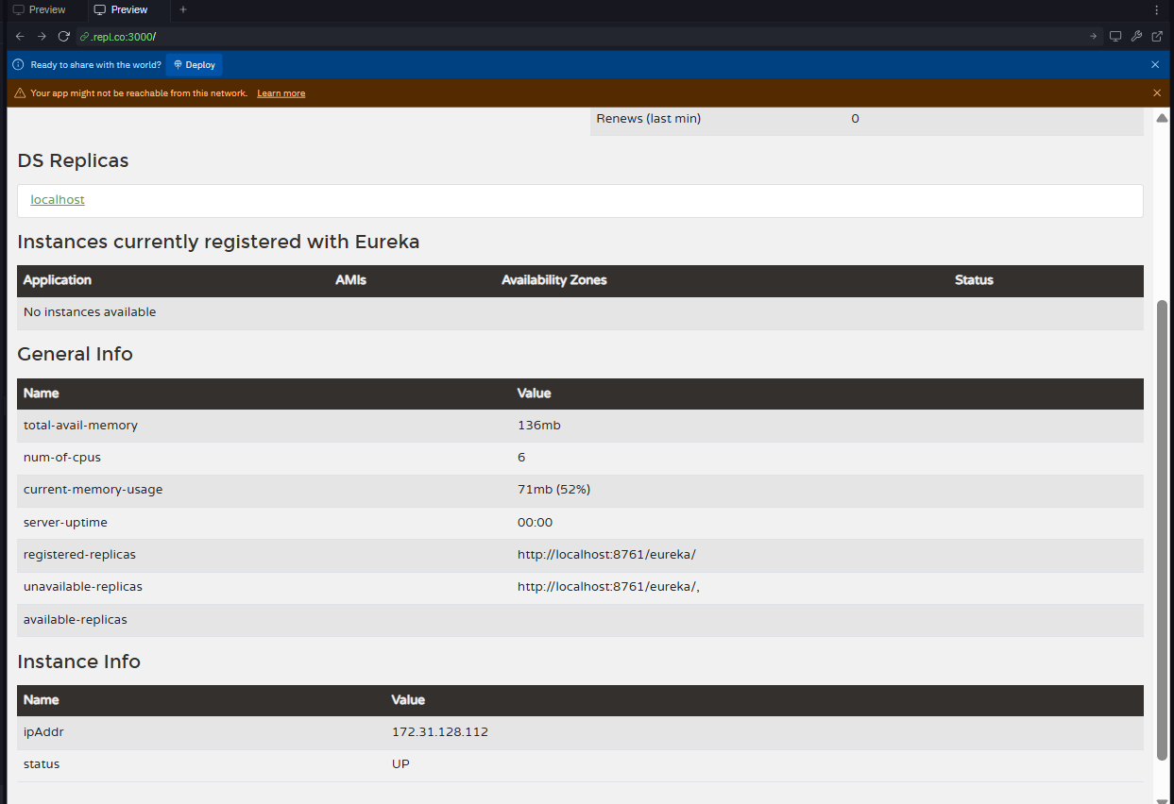

## Register Account REST API to eureka discovery

* Go to https://start.spring.io and provide the following configuration:
  + Group: com.cognizant
  + Artifact: account
  + Modules:
    - Spring Boot DevTools
    - Eureka Discovery Client
    - Spring Web
* Click "Explore", which will open pom.xml
* Use copy option in the opened window to copy the pom.xml and overwrite the pom.xml in account project
* Build the project using maven in console
* Include @EnableDiscoveryClient annotation to application class of account project
* Include application name for account application as specified below in application.properties. This is the name that will be displayed in the eureka discovery registry.

spring.application.name=account-service

* Stop all services (account, loan, eureka-discovery-server) using the console window of Eclipse. Use the monitor icon in console view to switch between applications and use the Terminate button to stop the server.
* First start eureka-discovery-server and wait till the application starts completely. Then open [http://locahost:8761](http://locahost:8761/) in browser. The service list should be empty.
* Then start account application and wait till the application starts.
* Refresh the eureka-discovery-server web page in browser, the account- service will be listed in the registry
* Perform similar steps for loan application and have it registered with eureka-discovery-server.

**Program:**

**account-service(folder):**

**pom.xml:**

<project xmlns="http://maven.apache.org/POM/4.0.0"

xmlns:xsi="http://www.w3.org/2001/XMLSchema-instance"

xsi:schemaLocation="http://maven.apache.org/POM/4.0.0

http://maven.apache.org/xsd/maven-4.0.0.xsd">

<modelVersion>4.0.0</modelVersion>

<groupId>com.cognizant</groupId>

<artifactId>api-gateway</artifactId>

<version>0.0.1-SNAPSHOT</version>

<packaging>jar</packaging>

<name>api-gateway</name>

<description>API Gateway for Microservices</description>

<parent>

<groupId>org.springframework.boot</groupId>

<artifactId>spring-boot-starter-parent</artifactId>

<version>3.1.5</version>

<relativePath/> <!-- lookup parent from repository -->

</parent>

<properties>

<java.version>17</java.version>

<spring-cloud.version>2022.0.4</spring-cloud.version>

</properties>

<dependencies>

<!-- Spring Cloud Gateway -->

<dependency>

<groupId>org.springframework.cloud</groupId>

<artifactId>spring-cloud-starter-gateway</artifactId>

</dependency>

<!-- WebFlux (used internally by Spring Cloud Gateway) -->

<dependency>

<groupId>org.springframework.boot</groupId>

<artifactId>spring-boot-starter-webflux</artifactId>

</dependency>

<!-- Eureka Client -->

<dependency>

<groupId>org.springframework.cloud</groupId>

<artifactId>spring-cloud-starter-netflix-eureka-client</artifactId>

</dependency>

<!-- Actuator -->

<dependency>

<groupId>org.springframework.boot</groupId>

<artifactId>spring-boot-starter-actuator</artifactId>

</dependency>

<!-- For LoggingFilter (uses Mono) -->

<dependency>

<groupId>io.projectreactor</groupId>

<artifactId>reactor-core</artifactId>

</dependency>

<!-- Testing -->

<dependency>

<groupId>org.springframework.boot</groupId>

<artifactId>spring-boot-starter-test</artifactId>

<scope>test</scope>

<exclusions>

<exclusion>

<groupId>org.junit.vintage</groupId>

<artifactId>junit-vintage-engine</artifactId>

</exclusion>

</exclusions>

</dependency>

</dependencies>

<dependencyManagement>

<dependencies>

<dependency>

<groupId>org.springframework.cloud</groupId>

<artifactId>spring-cloud-dependencies</artifactId>

<version>${spring-cloud.version}</version>

<type>pom</type>

<scope>import</scope>

</dependency>

</dependencies>

</dependencyManagement>

<build>

<plugins>

<plugin>

<groupId>org.springframework.boot</groupId>

<artifactId>spring-boot-maven-plugin</artifactId>

</plugin>

</plugins>

</build>

</project>

**application.properties:**

spring.application.name=account-service

server.port=8081

eureka.client.service-url.defaultZone=http://localhost:8761/eureka

**AccountApplication.java:**

package com.cognizant.account;

import org.springframework.boot.SpringApplication;

import org.springframework.boot.autoconfigure.SpringBootApplication;

import org.springframework.cloud.client.discovery.EnableDiscoveryClient;

@SpringBootApplication

@EnableDiscoveryClient

public class AccountApplication {

public static void main(String[] args) {

SpringApplication.run(AccountApplication.class, args);

}

}

**Output:**



Create a Spring Cloud API Gateway and call one microservice thru the API gateway. Configure a global filter to log each request targeting the microservice using Spring Cloud API Gateway.

Steps.

1. Create Simple Microservice **greet-service** that returns “Hello World” using Spring Initializer.
2. Select the latest version of Spring Boot and the dependencies as shown in the image below.

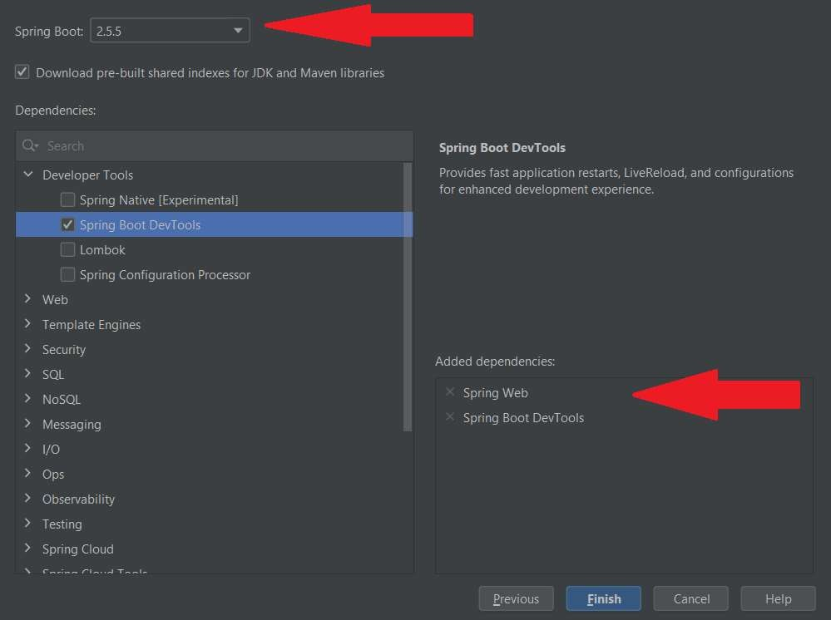

1. Configure the application name in “application.properties” as shown below

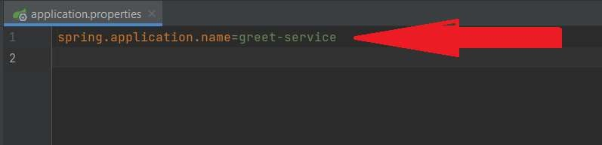

1. Create a controller as shown below.

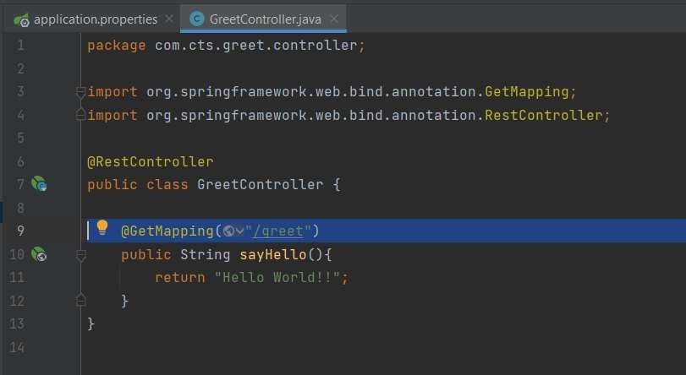

1. Run the microservice and make sure that it is working fine as shown below

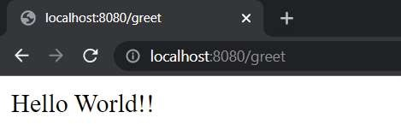

1. Create a second microservice that is acting as the Discovery Server using Spring Cloud Eureka Server.
2. Select the latest version of Spring Boot and the required dependencies as shown below

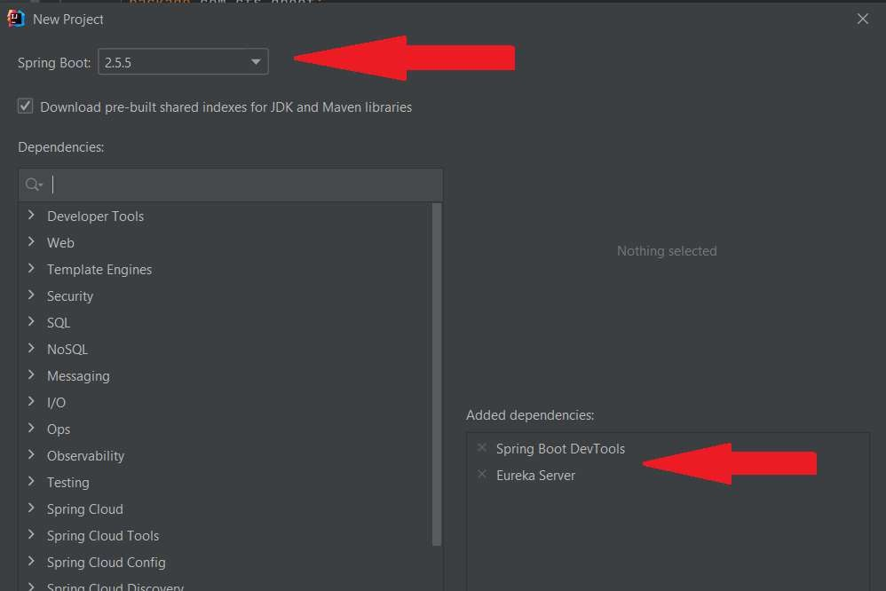

1. Include the following configurations in the “application.properties” of the Eureka server

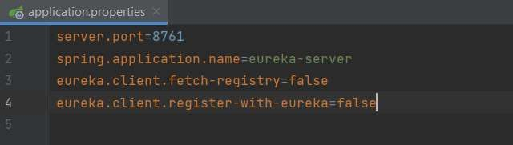

1. Annotate the main class in Eureka Server with @EnableEurekaServer as shown below.

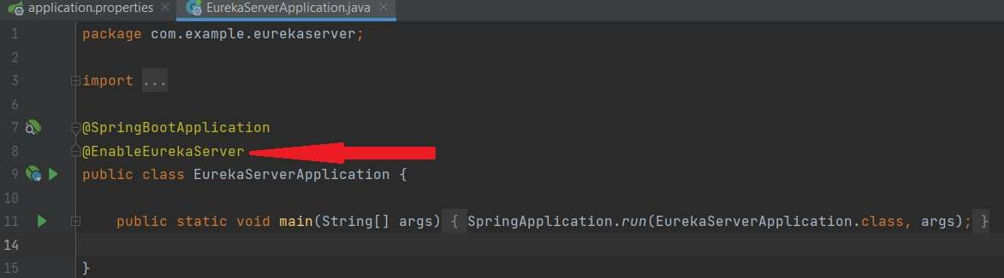

1. Run the Eureka Server and ensure that the server is functioning properly by entering the below URL at any of the browser.

[http://localhost:8761](http://localhost:8761/)

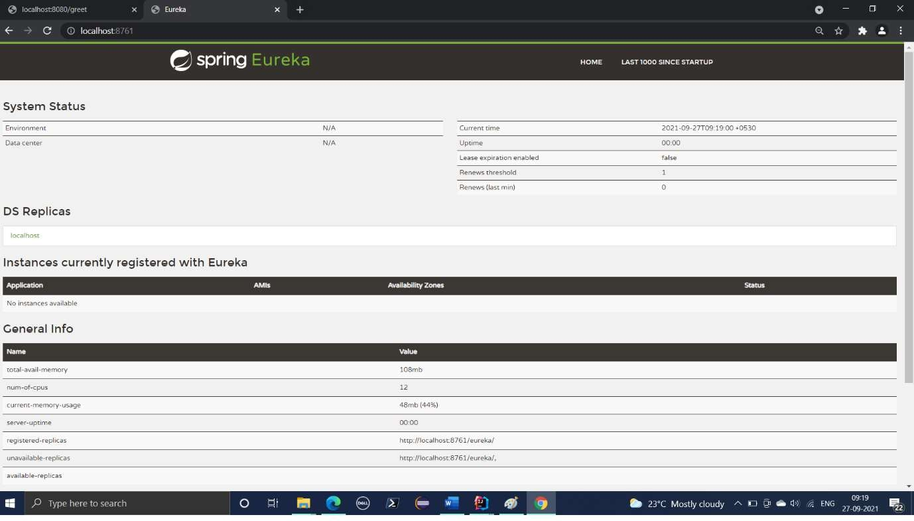

1. Open the pom.xml of greet-service microservice and add the eureka client dependencies as shown in the image below.
2. Copy the spring cloud version from pom.xml of eureka-server and paste it at the appropriate location in the pom.xml of greet-service as shown below.

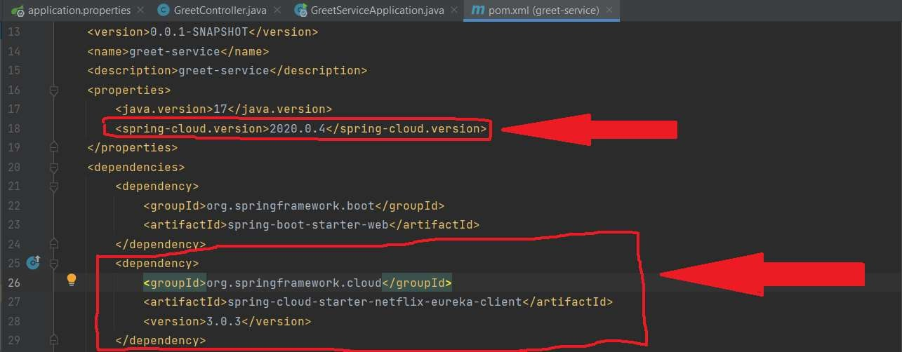

1. Copy the “dependency-management” session in the pom.xml of the eureka-server and paste it immediately after the dependencies session of the pom.xml of the greet-service as shown below.

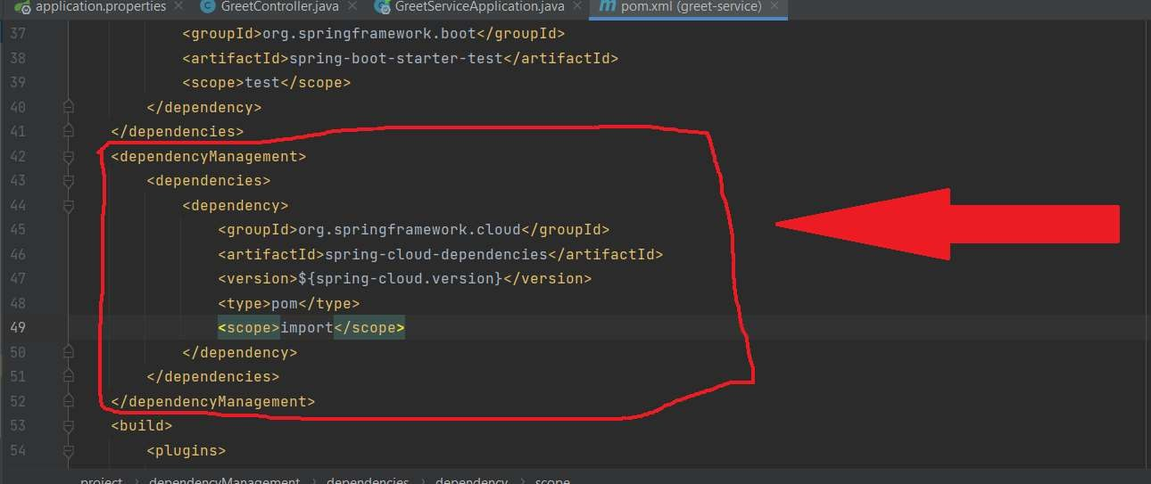

1. Restart greet-service and refresh the [http://localhost:8761](http://localhost:8761/) to see whether the name of the greet-service figuring in the eureka-server console as shown below.

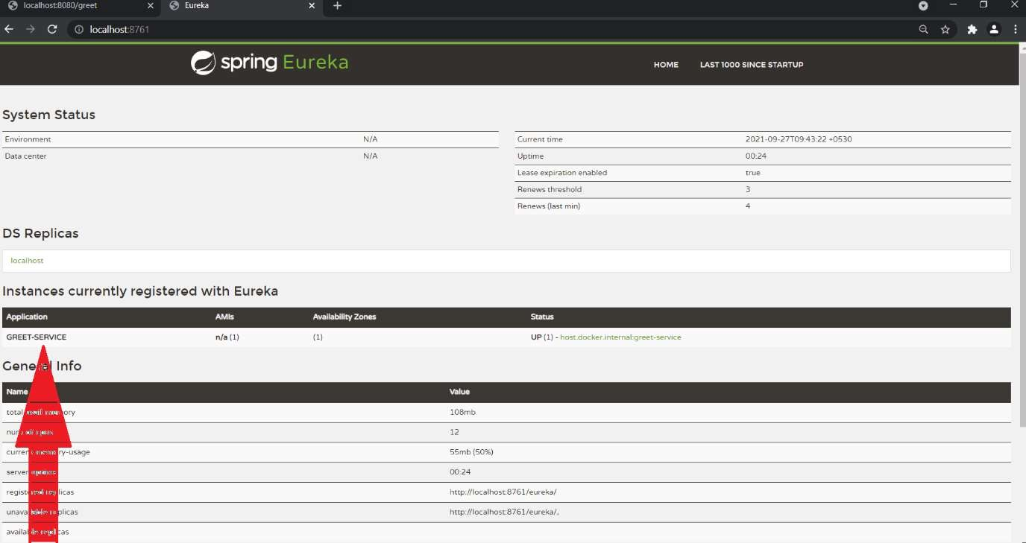

1. Create another microservice “api-gateway” using spring initializer.
2. Select the latest version of Spring Boot and add the required dependencies as shown below.

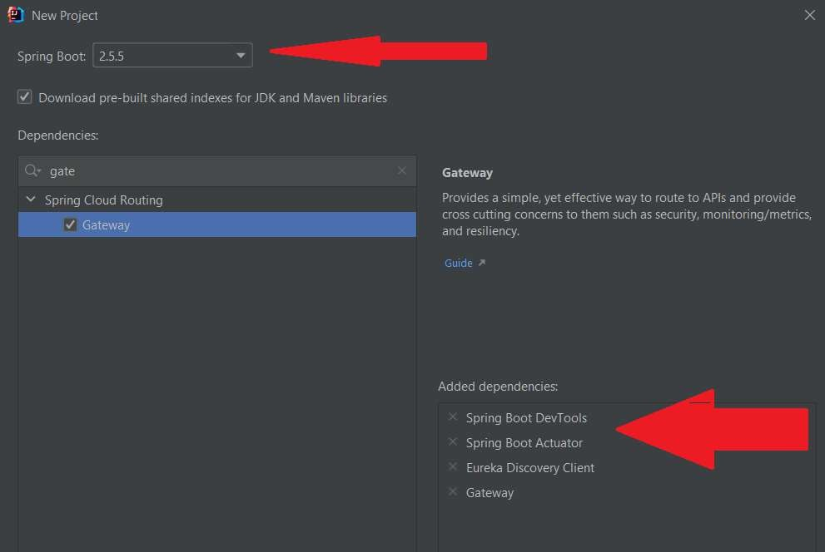

1. Make the necessary configurations in the “application.properties” file as shown below.

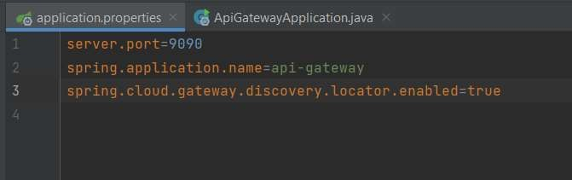

1. Run the api-gateway service and check if it is getting registered with the eureka-server.

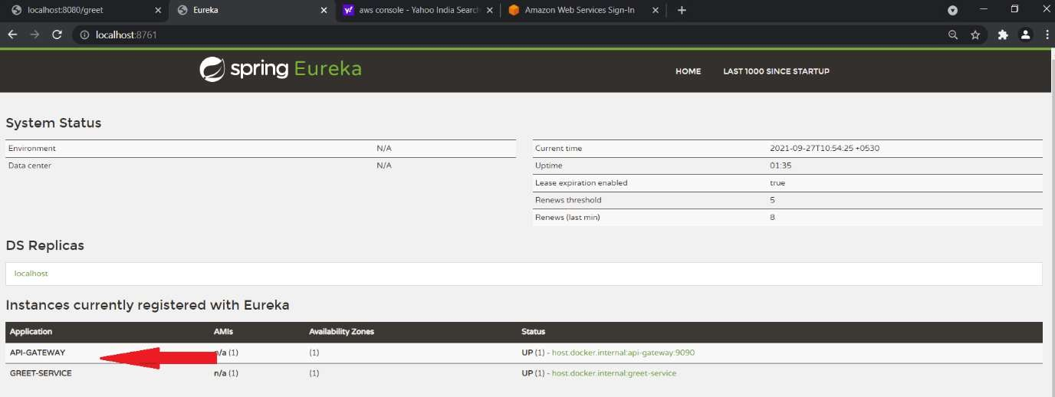

1. Try to access the following URL from any of the browser and see if you are able to access the greet-service thru the api-gateway.

<http://localhost:9090/GREET-SERVICE//greet>

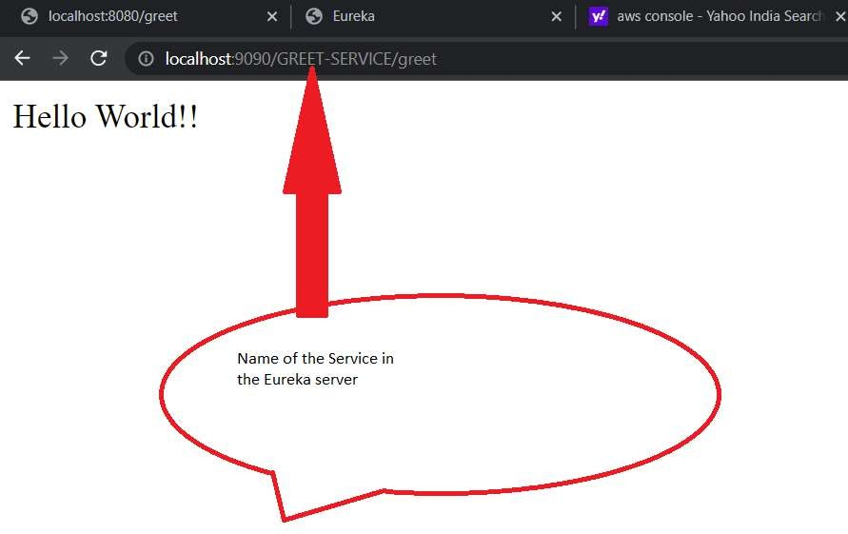

1. Include the following configuration in the “ application.properties” of the api-gateway to specify the service name in lower case.

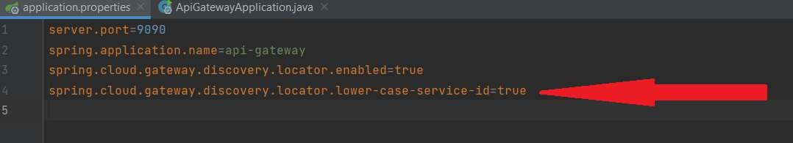

1. Implement a global filter which logs all incoming requests.
   1. Create a LogFilter class as shown below.

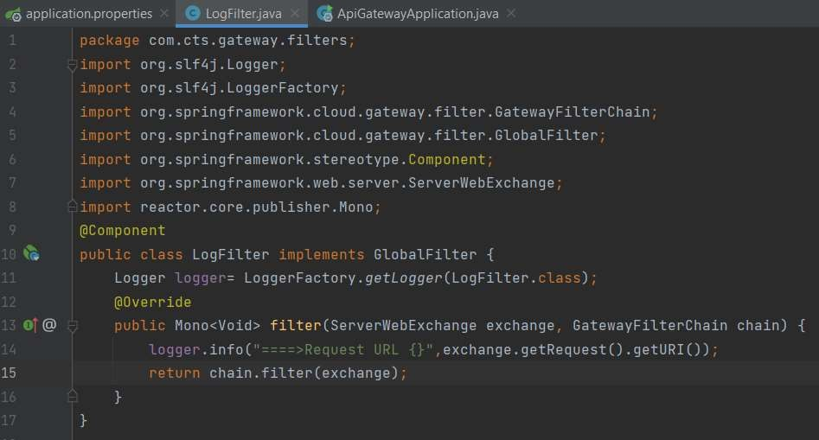

1. Try to access the url [http://localhost:9090/greet-service/greet.](http://localhost:9090/greet-service/greet) You will get the output as shown below.

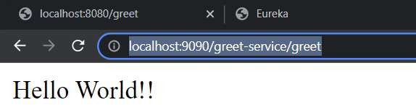

1. Check the console of the api-gateway service and you should be getting the log shown below.

**Program:**

**greet-service(folder):**

**GreetController.java:**

package com.cts.greet;

import org.springframework.web.bind.annotation.GetMapping;

import org.springframework.web.bind.annotation.RestController;

@RestController

public class GreetController {

@GetMapping("/")

public String home() {

return "Welcome to the Greet Service!";

}

@GetMapping("/greet")

public String greet() {

return "Hello from Greet Service!";

}

}

**GreetServiceApplication.java:**

package com.cts.greet;

import org.springframework.boot.SpringApplication;

import org.springframework.boot.autoconfigure.SpringBootApplication;

@SpringBootApplication

public class GreetServiceApplication {

public static void main(String[] args) {

SpringApplication.run(GreetServiceApplication.class, args);

}

}

**application.properties:**

spring.application.name=greet-service

server.port=8082

eureka.client.service-url.defaultZone=http://localhost:8761/eureka

eureka.client.register-with-eureka=true

eureka.client.fetch-registry=true

**pom.xml:**

<project xmlns="http://maven.apache.org/POM/4.0.0"

xmlns:xsi="http://www.w3.org/2001/XMLSchema-instance"

xsi:schemaLocation="http://maven.apache.org/POM/4.0.0

http://maven.apache.org/xsd/maven-4.0.0.xsd">

<modelVersion>4.0.0</modelVersion>

<groupId>com.cts</groupId>

<artifactId>greet-service</artifactId>

<version>0.0.1-SNAPSHOT</version>

<packaging>jar</packaging>

<name>greet-service</name>

<description>Greet Service for Spring Microservices</description>

<parent>

<groupId>org.springframework.boot</groupId>

<artifactId>spring-boot-starter-parent</artifactId>

<version>3.1.8</version>

<relativePath/>

</parent>

<properties>

<java.version>17</java.version>

</properties>

<dependencies>

<dependency>

<groupId>org.springframework.boot</groupId>

<artifactId>spring-boot-starter-web</artifactId>

</dependency>

<dependency>

<groupId>org.springframework.cloud</groupId>

<artifactId>spring-cloud-starter-netflix-eureka-client</artifactId>

</dependency>

<dependency>

<groupId>org.springframework.boot</groupId>

<artifactId>spring-boot-starter-actuator</artifactId>

</dependency>

<dependency>

<groupId>org.springframework.boot</groupId>

<artifactId>spring-boot-starter-test</artifactId>

<scope>test</scope>

</dependency>

</dependencies>

<dependencyManagement>

<dependencies>

<dependency>

<groupId>org.springframework.cloud</groupId>

<artifactId>spring-cloud-dependencies</artifactId>

<version>2022.0.4</version>

<type>pom</type>

<scope>import</scope>

</dependency>

</dependencies>

</dependencyManagement>

<build>

<plugins>

<plugin>

<groupId>org.springframework.boot</groupId>

<artifactId>spring-boot-maven-plugin</artifactId>

</plugin>

</plugins>

</build>

</project>

**Output:**

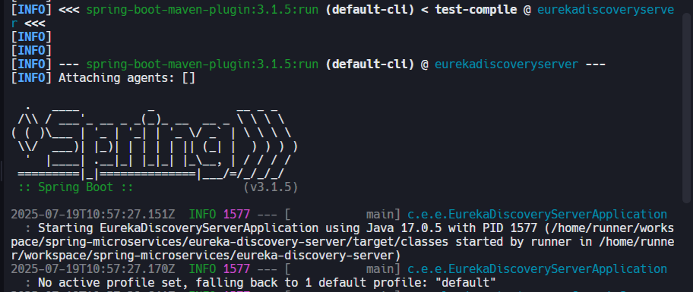

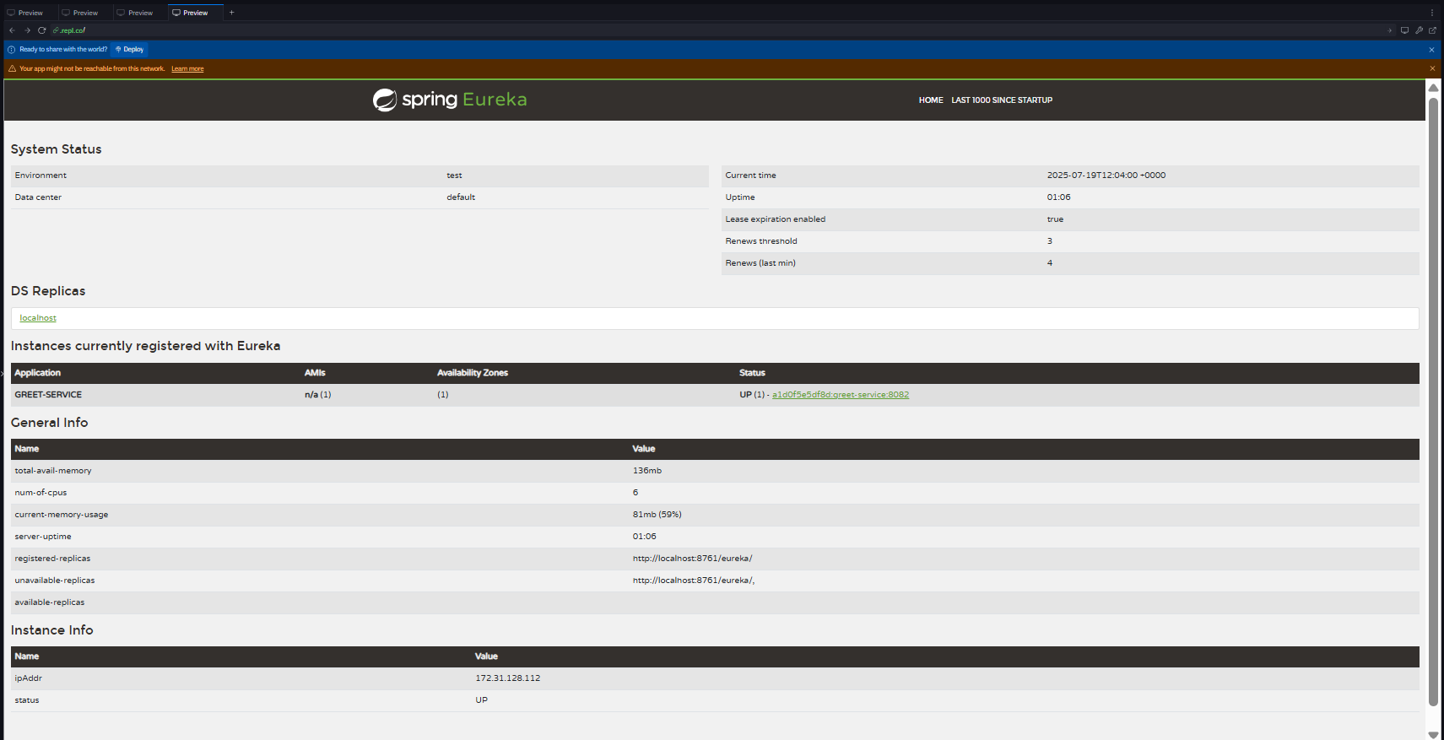

**api-gateway(folder):**

**LoggingFilter.java:**

package com.cognizant.gateway.filters;

import org.springframework.cloud.gateway.filter.GlobalFilter;

import org.springframework.cloud.gateway.filter.GatewayFilterChain;

import org.springframework.stereotype.Component;

import org.springframework.web.server.ServerWebExchange;

import reactor.core.publisher.Mono;

@Component

public class LoggingFilter implements GlobalFilter {

@Override

public Mono<Void> filter(ServerWebExchange exchange, GatewayFilterChain chain) {

System.out.println("Request received: " + exchange.getRequest().getURI());

return chain.filter(exchange);

}

}

**ApiGatewayApplication.java:**

package com.cognizant.gateway;

import org.springframework.boot.SpringApplication;

import org.springframework.boot.autoconfigure.SpringBootApplication;

import org.springframework.cloud.client.discovery.EnableDiscoveryClient;

@SpringBootApplication

@EnableDiscoveryClient

public class ApiGatewayApplication {

public static void main(String[] args) {

SpringApplication.run(ApiGatewayApplication.class, args);

}

}

**application.yml:**

server:

port: 8080

spring:

application:

name: api-gateway

cloud:

gateway:

routes:

- id: greet-service

uri: lb://greet-service

predicates:

- Path=/greet/**

discovery:

locator:

enabled: true

eureka:

client:

service-url:

defaultZone: http://localhost:8761/eureka

**loan-service(folder):**

**Loanapplication.java:**

package com.cognizant.loan;

import org.springframework.boot.SpringApplication;

import org.springframework.boot.autoconfigure.SpringBootApplication;

import org.springframework.cloud.client.discovery.EnableDiscoveryClient;

@SpringBootApplication

@EnableDiscoveryClient

public class LoanApplication {

public static void main(String[] args) {

SpringApplication.run(LoanApplication.class, args);

}

}

**application.properties:**

spring.application.name=loan-service

server.port=8082

eureka.client.service-url.defaultZone=http://localhost:8761/eureka

**Output:**

